**Install JAVA:**

1) Visit the [***Java downloads page on Oracle’s***](http://www.oracle.com/technetwork/java/javase/downloads/index.html) website to find the ***JDK environment*** download. Scroll down until you find ***Java SE Latest Version*** and download ***JDK***.

2) Once you have selected download, ***accept***the terms of service and choose the correct OS corresponding for the specific JDK. (Windows, Mac, Linux, etc.)

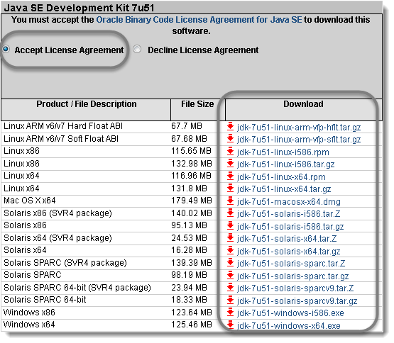

3) ***Save***the ‘**.exe**‘file to your disk.

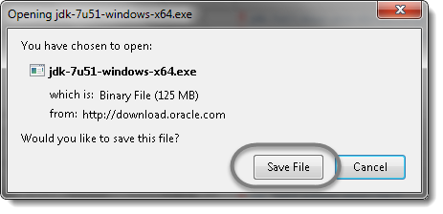

4) Once the download is complete, ***double click***the file to begin the installation of ***JDK***.

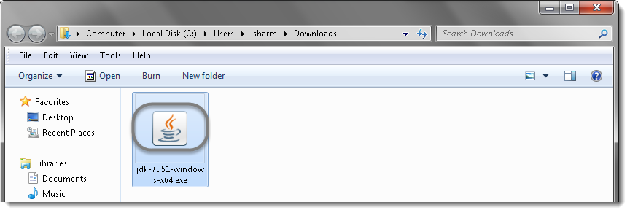

5) To run the installer, click***Run***.

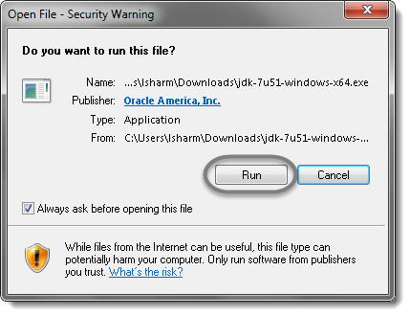

6) The installation process starts. Click the **Next**button to continue the installation.

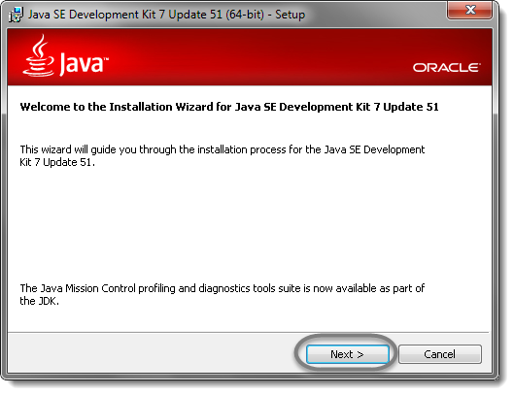

7) On the next screen you will encounter some options. Just leave these alone and click ***Next*** unless you know what you are doing.

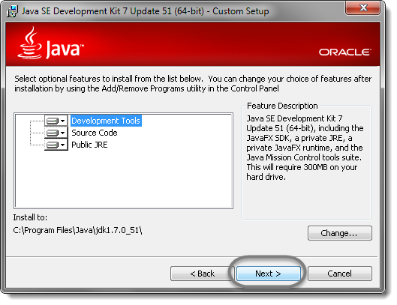

8) After the initial installation is done, a pop up asking you where your source java files will be. You can choose to change where you want to keep your folder but it’s best to stick with what you were given first. Click**Next** to continue.

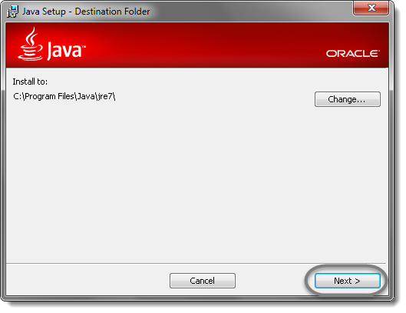

9) Let the installation finish.

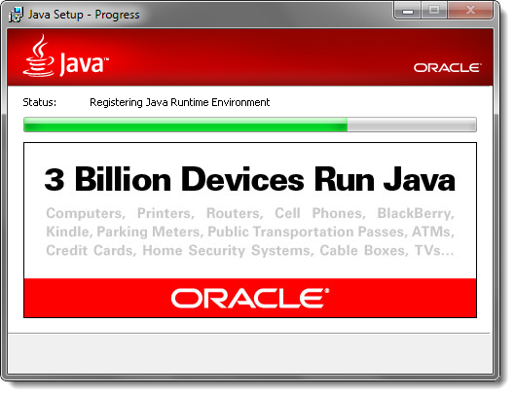

10) A few brief dialog confirm the last steps of the installation process; click**Close** on the last dialog. This will complete Java installation process.

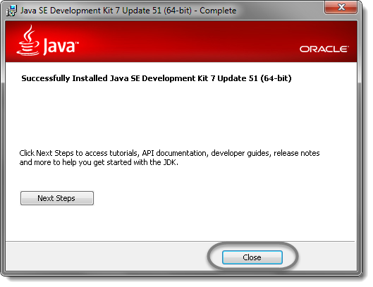

**Download Eclipse:**

Download Eclipse for Java Developers, extract and save it in any drive. It is totally free. You can run ‘eclipse.exe’ directly so you do not need to install Eclipse in your system.

1) Go to [***http://www.eclipse.org/download***s](http://www.eclipse.org/downloads).

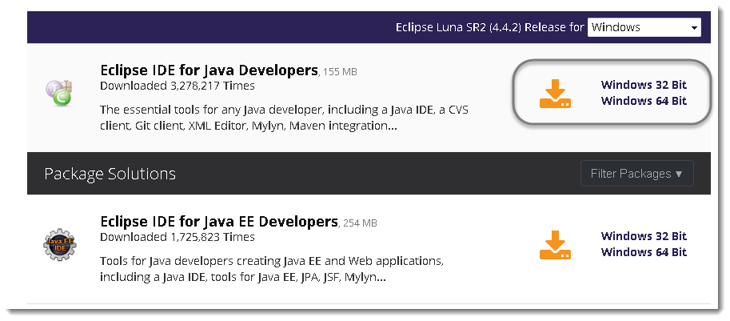

2) For Windows users, you will have to know what type of version of your ***OS***you have. If your computer is a***64 bit***Windows, select Windows 64 and if you have a***32 bit*** Windows, select Windows 32 bit.

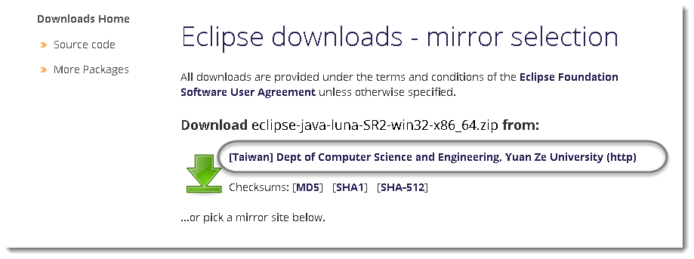

3) ***Save***the ***.zip*** file to your disk.

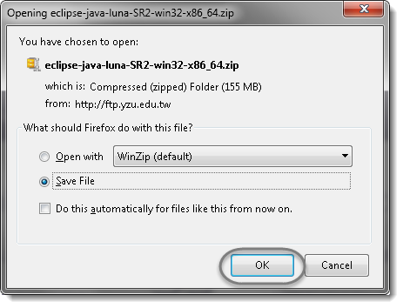

4) Once you have downloaded the Eclipse archive you will need to **Extract**the zip file, which will create the unzipped Eclipse folder.

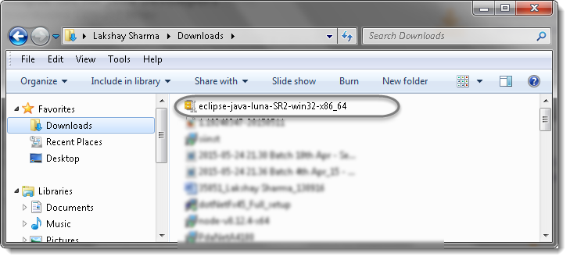

 5) You may want to ***Extract***the archive to the root of ***C: drive***, thus creating the folder “***C:\eclipse***”, or just moved the extracted eclipse folder to the root of C: drive if you extracted it already. I prefer to leave it as it is.

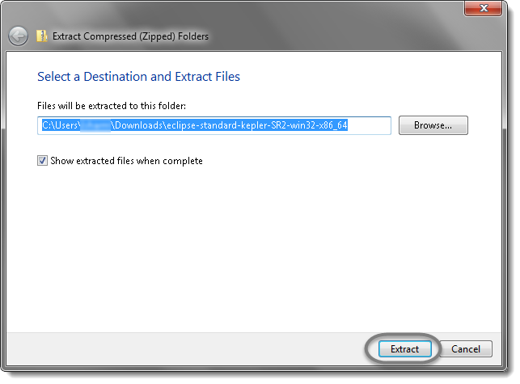

6) Let the extraction process finished.

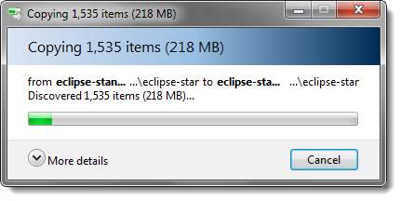

7) ***Open***the eclipse folder.

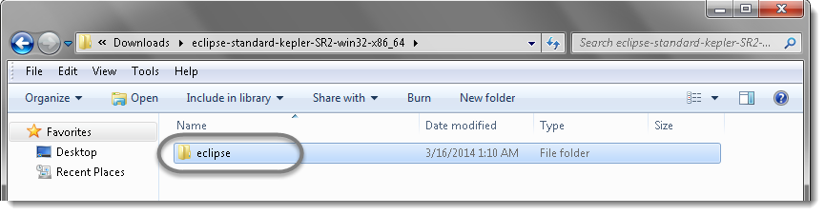

8) Since Eclipse IDE does not have any installer, there will be a file inside the Eclipse folder named ***eclipse.exe***. You can double click on the file to run Eclipse.

***Note :***( This step is not required, but it’s strongly recommended.) Right-click the Eclipse Icon and press “Send To” -> “Desktop (Create Shortcut).” Now you will be able to launch Eclipse from your desktop.

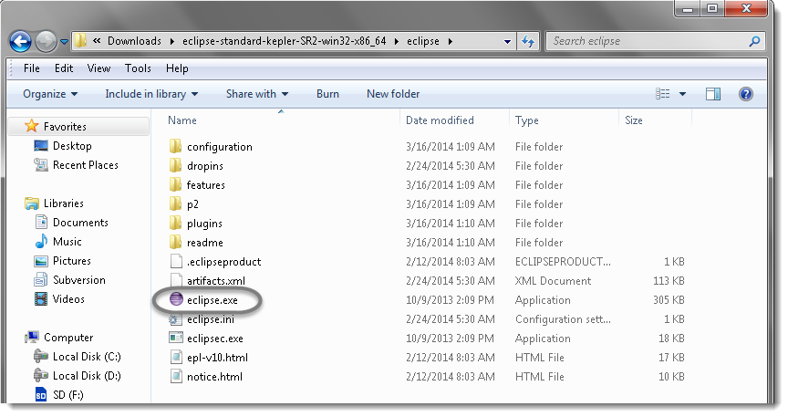

9) Create a ***workspace***folder where you will contain all the program files you create. You can choose whatever place you want for your workspace, but it’s easiest to just use the default you’re given.

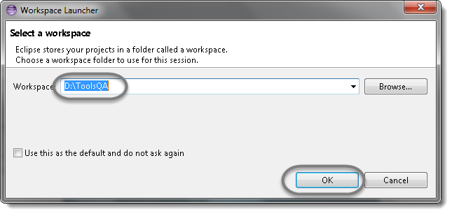

10) You may see the window like this, this is the Welcome window for Eclipse.

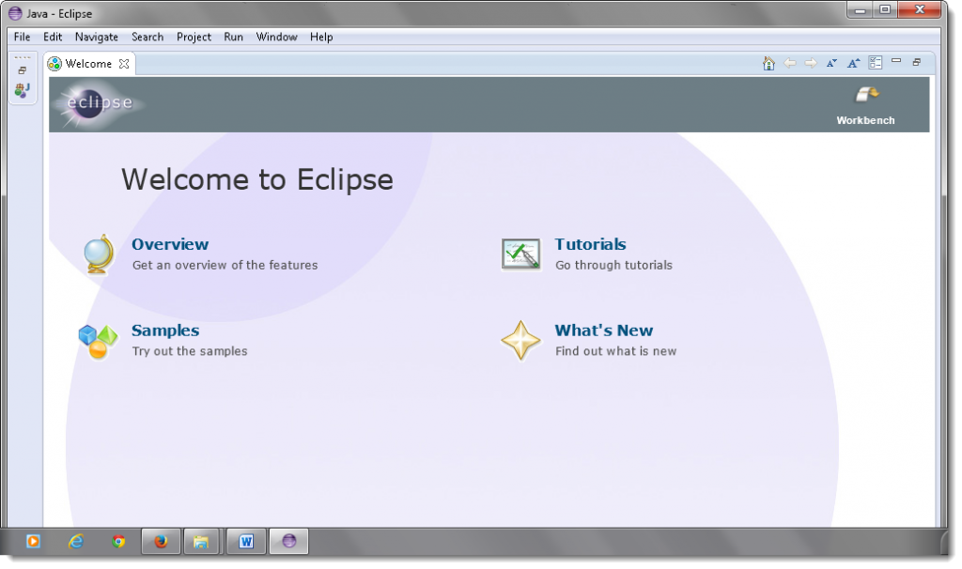

11) Now that you have finished installing eclipse restart your computer. By restarting your computer it refreshes system memory and allows changes made by installers and uninstallers to take effect.